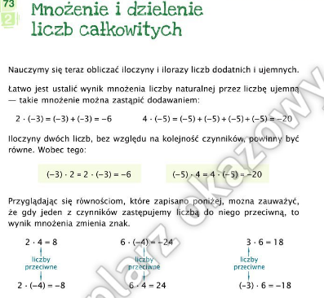

--------------------------------------------------------------------------------------------------------------------------------

1.)

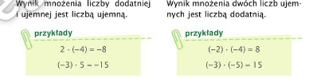

2.)

