Language Test A - Units 17-20
Vocabulary
1 Match the sentences 1-5 with the hobbies A-E
0 I make my sculptures in clay. __F__
1 I like decorating clothes. _____
2 I’ve made a chair and a table for my little brother. _____
3 I like finding caves in the rocks _____
4 I love flying _____
5 I make necklaces with beads. _____

A) making jewellery
B) potholing
C) hang-gliding
D) woodwork
E) embroidery
F) sculpture
/ 5
2 Complete. Use the words in the box.
basket / bowl / brush / collar / food / lead
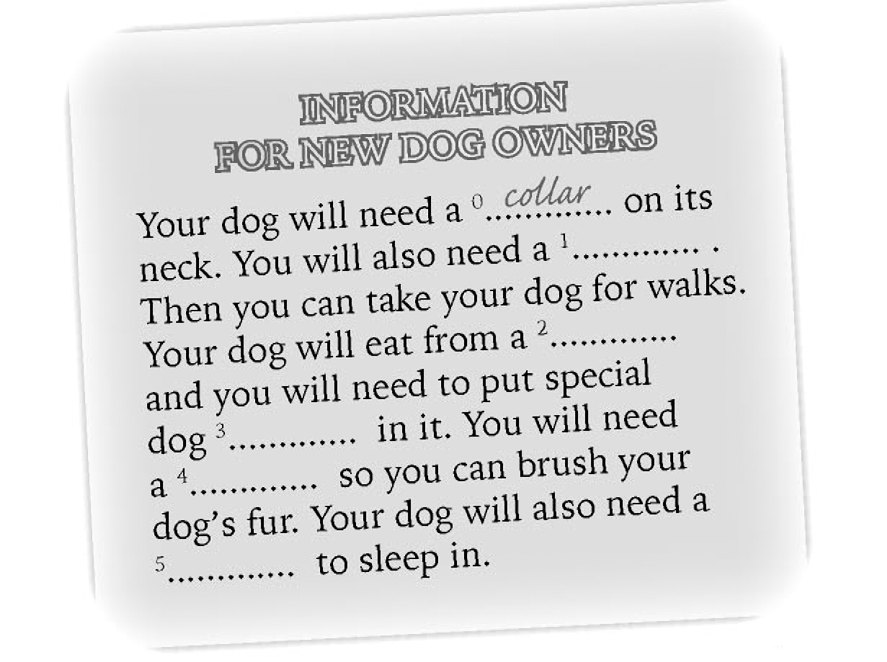
/ 5

Language in Context
3 Circle the correct answer – A, B. or C.
0 Have you ever won anything?
A) Yes – the prize was great!
B) Yes – I’ve had an injection.
C) Yes – I’ve been to Italy.
1 Did she go to Spain last year?
A) Yes, she’s been to Spain.
B) Yes, she went there in July.
C) Yes, she has.
2 Have they painted the beads?
A) No, they haven’t – they haven’t decided on the colour yet.
B) Yes, they have. They’ve made them from clay.
C) Yes, they’ve built them.
3 Has the spaceship arrived yet?
A) Yes, it disappeared from the screen.
B) No, it’s in the space station.
C) Yes, but there is nobody there!
4 Have you ever found anything valuable?
A) Yes, I found some jewellery last year.
B) Yes, I’ve found a stray cat.
C) Yes, I’ve found some wooden beads.
5 Have you ever eaten snails?
A) Yes – they are hungry.
B) No – they are disgusting!
C) Yes – I’ve gone to lunch.
/ 5

4 Match 1-5 with A-E to make short conversations.
0 Have you fed the dogs? ___F_
1 Have you brushed them? _____
2 Have they been for a walk? _____
3 Has Timmy had his injection? _____
4 When was his last injection? _____
5 How many injections has he had? _____

A) No, I haven’t.
B) Yes, they went to the park this morning.
C) No, he hasn’t had it yet.
D) It was in January.
E) He’s had two.
F) Yes, I fed them at six o’clock.
/ 5

Grammar
5 Complete. Use the words in the box.
somebody / somewhere / anything / anybody / anywhere / nothing / nobody
0 Who did you see there?
I didn’t see ___anybody_____ there.
1 What did you eat at the restaurant?
I didn’t eat _______________ at the restaurant.
2 I want to go _______________.
3 Was there anybody in the room?
No, there was _______________ there.
4 Have they got something in that bag?
No, there’s _______________ in the bag.
5 Have you found the swimming costume?
No, I can’t find it _______________
6 What happened? Why aren’t you moving?
Be quiet! _______________ is knocking on the door.
/ 6
6 Complete. Use the Present Perfect or the Past Simple.
My hobby is making bags. I decorate them with beads and embroidery. I (not / ever / sell) ⁰.__haven’t ever sold_ any bags, but I (give) ¹___________________ some to my friends. Last month I (make) ²_____________________ a beautiful bag for my mum’s birthday. The bag (be) ³_________________ black and I (decorate) ⁴_________________ it with red beads. My sister is not really good at making things with her hands -her hobby is writing stories. She (write) ⁵__________________ her first story when she was five years old! She (already / write) ⁶____________________ lots of short stories and poems. Last year there (be) ⁷__________________ a poetry competition in her school. She (win) ⁸________________ a great prize – a laptop computer! Now she writes her stories on it!
/ 8

7 Write sentences. Use the Present Perfect.
0 you / ever / see / a ghost
__Have you ever seen a ghost__?
1 you / ever / go / China
__________________________________________________?
2 he / take / the exam / yet
__________________________________________________.
3 she / just / eat / lunch
__________________________________________________.
4 they / have / the injections / yet
__________________________________________________?
5 we / ever / eat / snails
__________________________________________________?
6 I / never / go / China
__________________________________________________.
6

TOTAL |  | / 40

