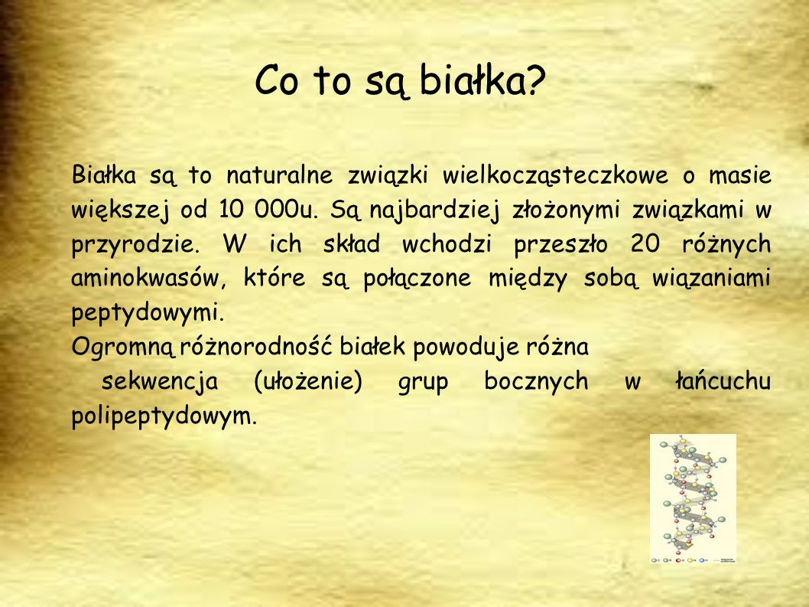

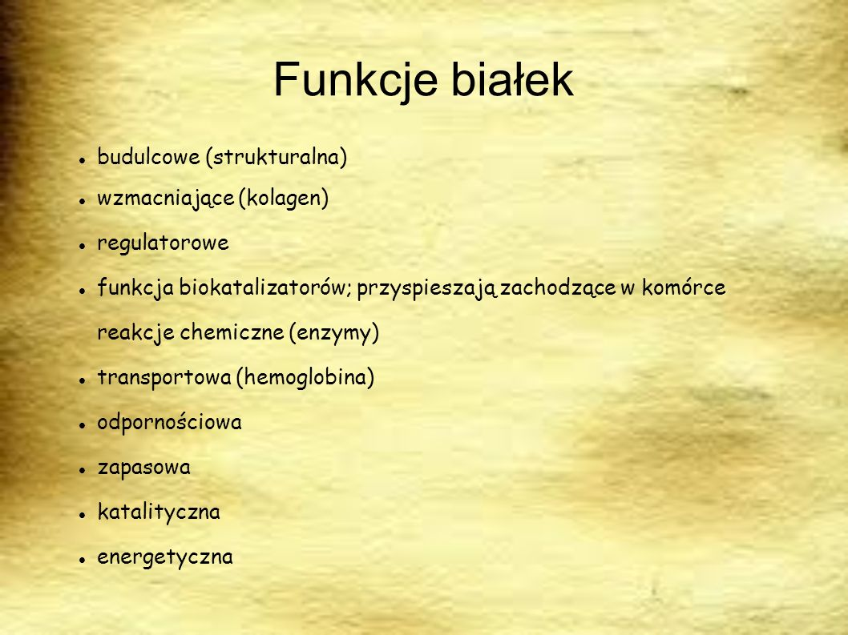

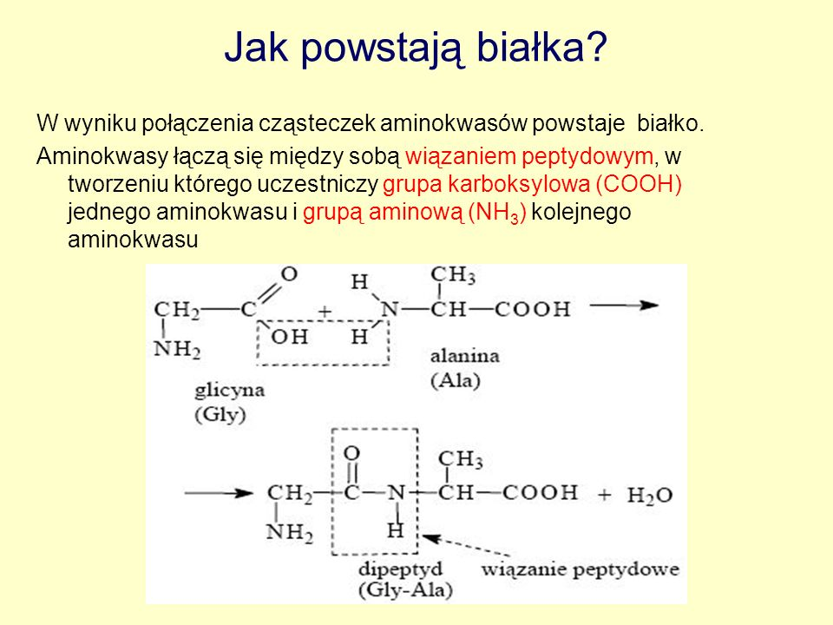

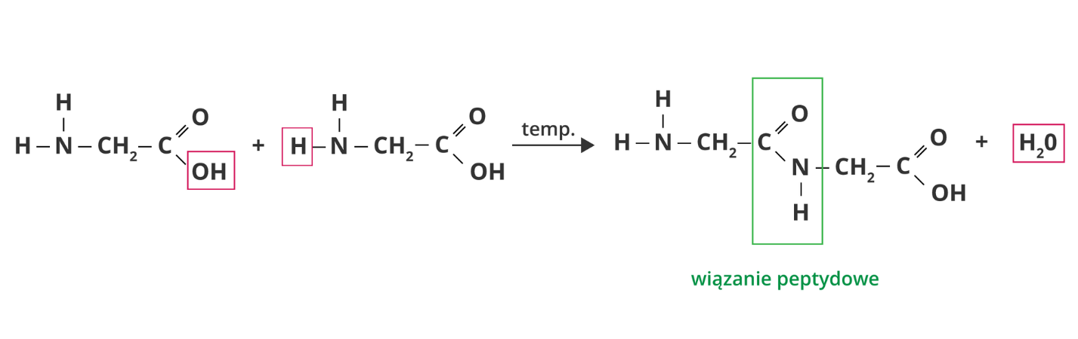

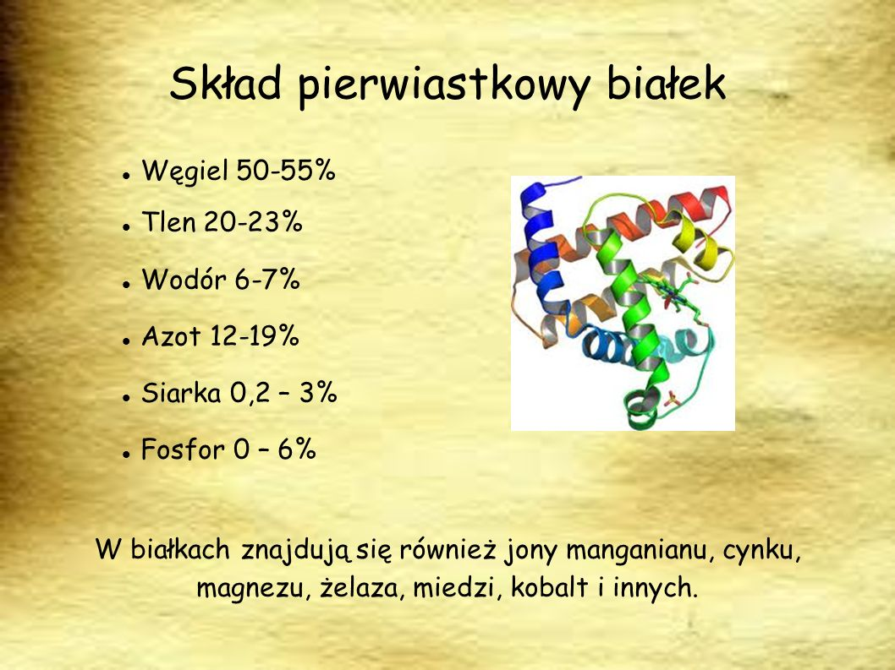

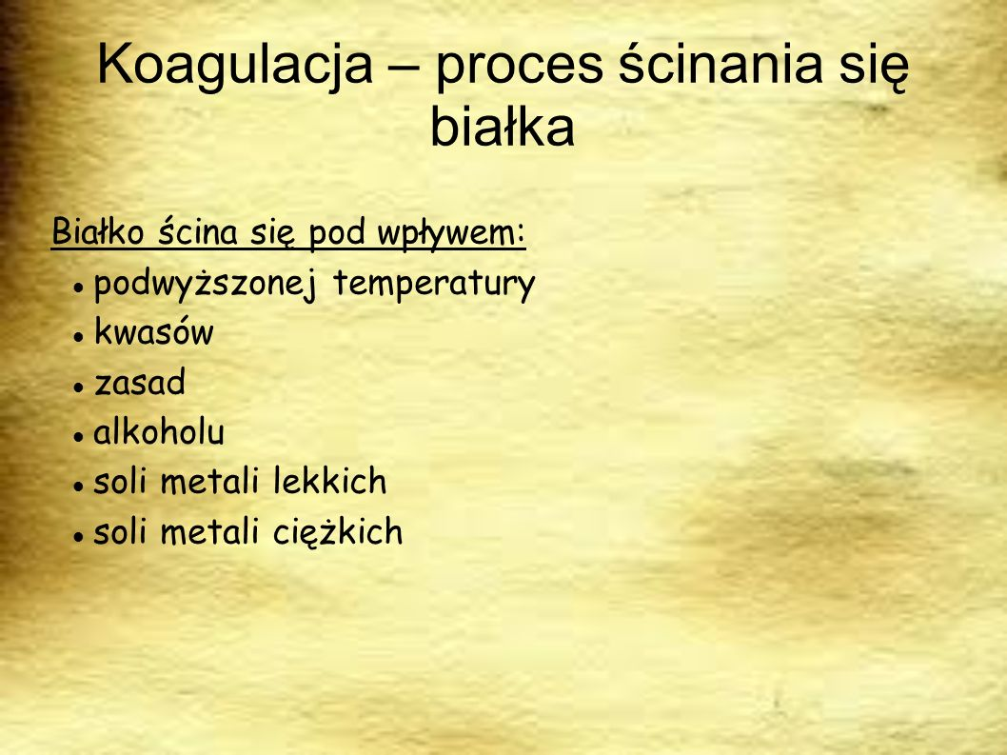

<https://www.youtube.com/watch?v=US45pPbw0jw>

<https://www.youtube.com/watch?v=3f0GrTdWyrQ>

<https://www.youtube.com/watch?v=TVSw-VMo2ZY>